Class Test 04
Table: Student_info
S_Id | S_Name | S_CGPA | S_BloodStatus | S_BloodGroup | a_id
1 | Mira | 3.59 | Halfblood | O+ | 11
2 | Rahman | 3.90 | Pureblood | A+ | 11
3 | Sharon |  | Pureblood | B+ | 22
4 | Caprio | 3.21 | Pureblood | AB+ | 22
5 | Winslet | 3.55 | Muggleborn | AB- | 33
6 | Khadija | 2.85 |  | O- | 33
7 | Shekhar | 2.30 | Pureblood | O+ | 44
8 | Florina | 3.10 | Pureblood | B+ | 44
Table: Address
a_id | city | country | Country_code
11 | Dhaka | Bangladesh | 101
22 | Doha | Qatar | 102
33 | Washington D.C | USA | 103
44 | London | UK | 104

Write down the queries of the following questions:
- Display the name, CGPA, (CGPA-0.5) of the students from the Student_info table.
- Display country and country code together as “Country_info” using concatenation function.
- Display the student name and student blood status with the column name “Student Name” and “Student Blood Status” from Student_info.
- Display all students who have only one ‘o’ in their name.
- Display the student name , CGPA who have null value in their CGPA.
- Display the city, country, country_code and those must be shown from highest numbered country code to lowest numbered country code.
- Display the student name, student CGPA and student blood status together where the blood status is pureblood using SUBSTR.
- Show all the students with their CGPA and blood status. If there is any null value use NVL function.
- Find out the student who is holding maximum CGPA.
**Solve the above questions (1 to 9) with SQL. Afterwards solve the same questions with PL/SQL. Write down the answer and give screenshot of the results of the query in a MS Word document. You must use Oracle 10g.The name of the document MUST be your ID (solutions MUST be numbered accordingly) and upload it in the provided link in your VUES account

- Display the name, CGPA, (CGPA-0.5) of the students from the Student_info table.
DECLARE
CURSOR student_cursor IS
SELECT S_Name, S_CGPA, (S_CGPA - 0.5) AS Adjusted_CGPA
FROM Student_info;
BEGIN
FOR student IN student_cursor LOOP
DBMS_OUTPUT.PUT_LINE('Name: ' || student.S_Name ||
', CGPA: ' || student.S_CGPA ||
', Adjusted CGPA: ' || student.Adjusted_CGPA);
END LOOP;
END;
/
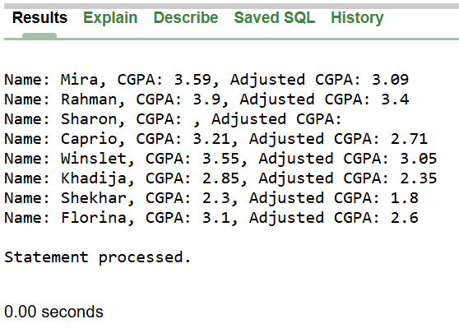

2. Display country and country code together as “Country_info” using concatenation function.
DECLARE
CURSOR address_cursor IS
SELECT country || ' (' || country_code || ')' AS country_info
FROM address;
BEGIN
FOR addr IN address_cursor LOOP
DBMS_OUTPUT.PUT_LINE(addr.country_info);
END LOOP;
END;
/
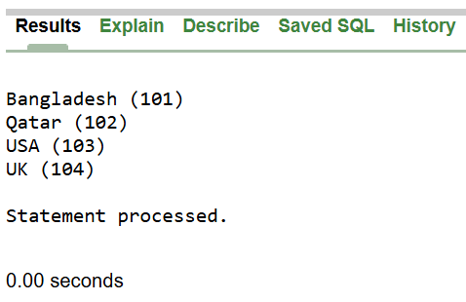

3. Display the student name and student blood status with the column name “Student Name” and “Student Blood Status” from Student_info.
DECLARE
CURSOR student_cursor IS
SELECT S_Name AS "Student Name", S_BloodStatus AS "Student Blood Status"
FROM Student_info;
BEGIN
FOR student IN student_cursor LOOP
DBMS_OUTPUT.PUT_LINE('Student Name: ' || student."Student Name" ||
' - ' || 'Student Blood Status: ' || student."Student Blood Status");
END LOOP;
END;
/
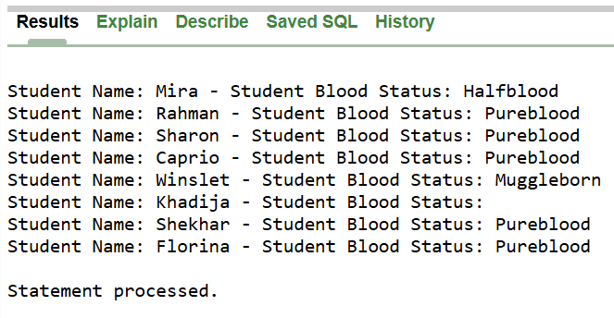

4. Display all students who have only one ‘o’ in their name.
BEGIN
FOR rec IN (SELECT S_Name FROM Student_info WHERE (LENGTH(LOWER(S_Name)) - LENGTH(REPLACE(LOWER(S_Name), 'o', ''))) = 1)
LOOP
DBMS_OUTPUT.PUT_LINE(rec.S_Name);
END LOOP;
END;
/
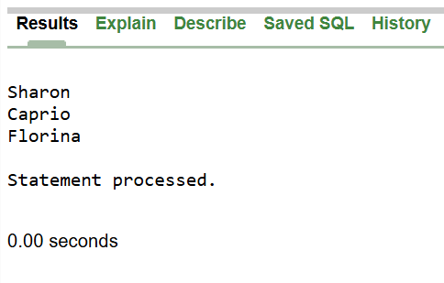

5. Display the student name , CGPA who have null value in their CGPA.
BEGIN
FOR student IN (SELECT S_Name FROM Student_info WHERE S_CGPA IS NULL)
LOOP
DBMS_OUTPUT.PUT_LINE('Student: ' || student.S_Name || ' has NULL CGPA');
END LOOP;
END;
/

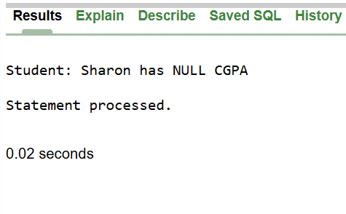

6. Display the city, country, country_code and those must be shown from highest numbered country code to lowest numbered country code.
BEGIN
FOR rec IN (
SELECT city, country, country_code
FROM Address
ORDER BY country_code DESC
)
LOOP
DBMS_OUTPUT.PUT_LINE('City: ' || rec.city || ' - Country: ' || rec.country || ' - Country Code: ' || rec.country_code);
END LOOP;
END;
/
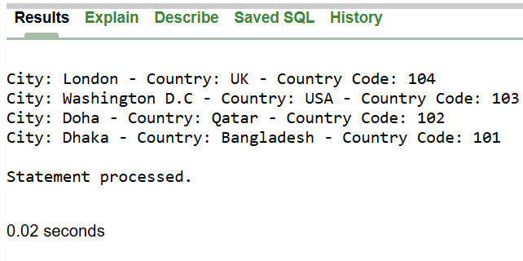

7. Display the student name, student CGPA and student blood status together where the blood status is pureblood using SUBSTR.
BEGIN
FOR student IN (
SELECT S_Name, S_CGPA, SUBSTR(S_BloodStatus, 1, 9) AS Blood_Short
FROM Student_info
WHERE S_BloodStatus = 'Pureblood'
) LOOP
DBMS_OUTPUT.PUT_LINE('Name: ' || student.S_Name || ' - ' || 'CGPA: ' || student.S_CGPA || ' - ' || 'Blood Status: ' || student.Blood_Short);
END LOOP;
END;
/

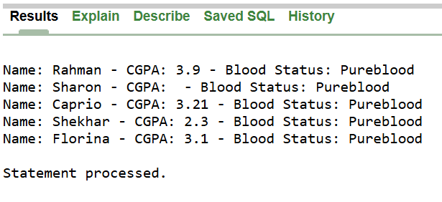

8. Show all the students with their CGPA and blood status. If there is any null value use NVL function.
BEGIN
FOR student IN (
SELECT S_Name, NVL(TO_CHAR(S_CGPA), 'N/A') AS CGPA, NVL(S_BloodStatus, 'N/A') AS Blood_Status
FROM Student_info
)
LOOP
DBMS_OUTPUT.PUT_LINE('Student: ' || student.S_Name || ' - ' || 'CGPA: ' || student.CGPA || ' - ' || 'Status: ' || student.Blood_Status);
END LOOP;
END;
/

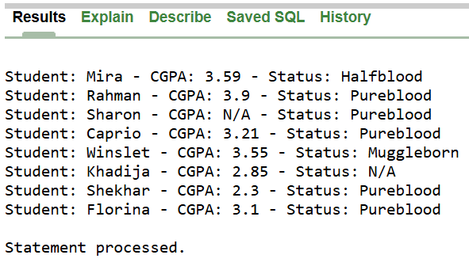

9. Find out the student who is holding maximum CGPA.
BEGIN
FOR student IN (SELECT S_Name, S_CGPA
FROM Student_info
WHERE S_CGPA = (SELECT MAX(S_CGPA) FROM Student_info)
)
LOOP
DBMS_OUTPUT.PUT_LINE('Top Student: ' || student.S_Name || ' with CGPA: ' || student.S_CGPA);
END LOOP;
END;
/



